How Do Physicists and Biologists Unravel the Mystery of Genetic Code?
by Qing-jun Wang

Ever since the discovery of the DNA structure by Watson and Crick in 1953, the flow of genetic information from DNA to proteins, which perform physiological functions in living organisms, has been quite intriguing to researchers. The association of 64 triplets of RNA nucleotide U, C, A and G to 20 amino acids and a stop signal, namely, genetic code, was discovered in 1966 by Brenner and Crick. However, the fundamental reasons behind the association, if there is any, remain mysterious. Physicists and biologists put their efforts on completely different aspects of this subject. Therefore, this paper tries to bring together the physics and biology point of views of genetic code. Hopefully , a better understanding can be achieved.

To a physicist, the world is simple. There are universal and simple laws govern any seemly complicated phenomenon. With this believing in mind, physicists started out to study the genetic code by looking for empirical relations between chemical compositions of RNA molecules and amino acids.
The RNA molecules, with bases pyrimidine Uracil and Cytosine and purine Adenine and Guanine, respectively, are progressively larger in size essentially due to the relative number of carbon, nitrogen and oxygen atoms in the bases. The size index of a base is expressed by
n(X)=2(n_{N}- n_{C})+n_{O}+2, (1)
where n_{C}, n_{N} and n_{O} are the number of carbon, nitrogen and oxygen atoms in the base X and hydrogen content is ignored. The molecular formulae and size indexes for the four bases are as follows:
uracil: C₄N₂O₂, n(U)=0,
cytosine: C₄N₃O, n(C)=1,
adenine: C₅N₅, n(A)=2,
guanine: C₅N₅O, n(G)=3,
Therefore, the genetic codon 5’(XYZ)3’ can be given a unique codon number
n(XYZ)=4n(X)+16n(Y)+n(Z)+1. (2)
The standard textbook representation of the genetic code can therefore be annotated with codon numbers given by formula (2) and the correspondence between codons and codon numbers is one-to-one (see Table). All amino acids other than Ser and Arg and stop codon are consecutively and vertically recurred in the standard genetic code representation. This continuity can be explained by that the first and second bases of a codon is more important than the third base. However, there is no simple and evident explanation for the discontinuity of the recurrence of stop codon and codons for Ser and Arg. The discontinuity may not be intrinsic to the codon itself but rather due to a deficiency in the standard textbook representation of the codon-to-amino-acid association. To achieve connectedness while maintaining successive codons staying close to each other, a rook’s tour of the two-dimensional structural map of the amino acid space was introduced(see Figure 1). In this space, the stop codons and the codons for Ser and Arg stay in continuous squares. The rook moves on the chess board from square to adjacent square and make a 64-non-repeated-step traversal of the amino acid space structural map. The i^{th} square reached by the root is given the codon number i. The codon 5’(XYZ)3’ can be obtained by solving the equation
i=4n(X)+16n(Y)+n(Z)+1. (3)
for n(X), n(Y) and n(Z).

Table. Universal genetic code with codon numbers (Rosen 1991).

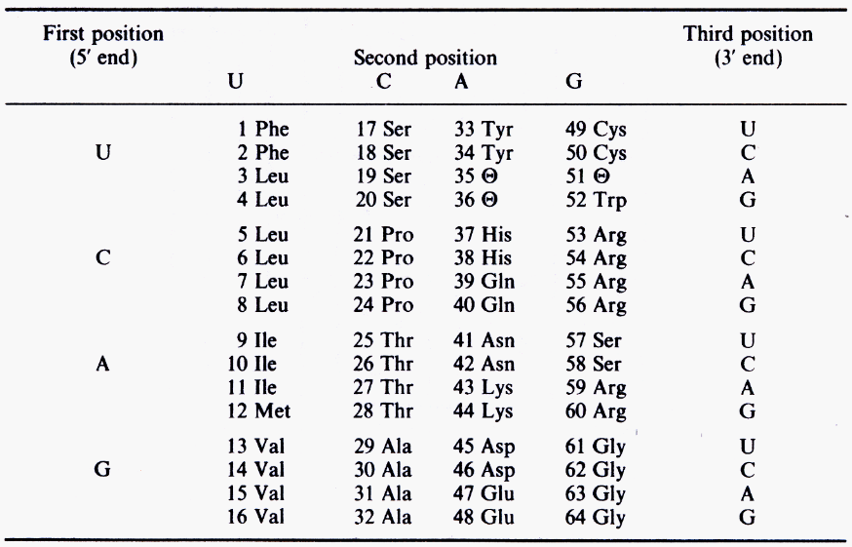

Figure 1. The rook’s tour presentation for codon numbers in amino acid structural map (Rosen 1991).
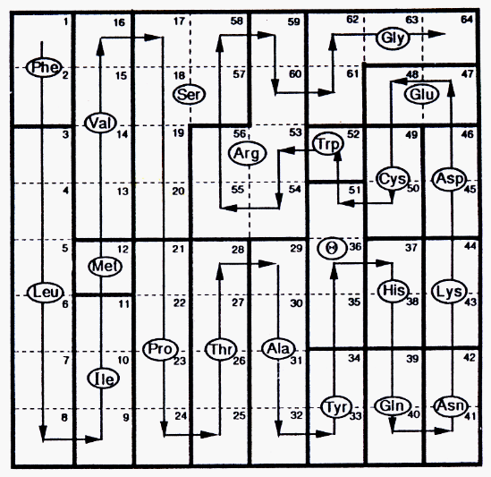

Futhermore, the 20 amino acids can be divided into four subclasses, depending on their codon range numbers (i.e. the smallest and largest codon numbers for each amino acid, designated as n_{i} and n_{f}) and the number of carbon, nitrogen, oxygen and sulfur atoms in each amino acid (designated n_{C}, n_{N}, n_{O}, and n_{S}).
Subclass I: 2n_{f} - n_{i} = 49-6n_{C} -7n_{S} +8r, (4)
Subclass II: n_{f} = 2(2-r)(2n_{C} –1), (5)
Subclass III: n_{f} = 14+6(n_{N}+ n_{O} + n_{S})±2(n_{C} -3), (6)
Subclass IV: 3n_{f} - 2n_{i} = 90-2n_{C}– 8n_{O}, (7)
where r=0 for amino acids without a ring and r=1 for amino acids with a ring, ±=+1 for n_{N}≠3 and n_{O}≠3 and ±=-1 for n_{N}=3 or n_{O}=3.
In conclusion, the molecular content theory says that the universal genetic code is essentially a relation between the number of carbon, nitrogen, oxygen and sulfur atoms in a amino acids and the number of carbon, nitrogen and oxygen atoms in the three bases of the associated codon, with codon numbers serving as the bridge. It is a conclusion that both physicists and biologists may not be satisfactory with.
For a physicist, this conclusion is merely a empirical rule. It is at most a “periodic table of elements for biology” with some knowledge of atom sizes and reactivities. It does not explain the reasons why the periodic table of elements is just the way it is.
For a biologist, he/she would notice that the universal genetic code is a special case. There are at least tens of variants of the universal genetic code. Is the molecular content theory general for every one of the variant genetic code? For a biologist, he/she is always looking for biological meanings/consequences/functions. One of several such questions he/she may ask is that: is there a biological explanation for dividing the 20 amino acids to four subclasses? For a biologist, he/she always keeps in mind that the subject is alive. A pile of carbon, nitrogen, oxygen and sulfur atoms is never a life. The molecular content theory apparently filters out a lot of important information (such as control theory) about the association of amino acids to bases.

For physicists pursuing the fundamental reasons why the genetic code is just the way it is, they found an outstanding feature of the genetic code – degeneracy. A golden rule in physics is that “degeneracy is associated with and a consequence of symmetry”. Therefore, the degeneracy of the genetic code reflects a symmetry that acts as an organizing principle for the association of twenty amino acids and four bases. Phase transition is often associated with changes in symmetry. For instance, freezing of water to ice is a phase transition accompanied by the breaking of the continuous translational and/or rotational symmetry to a discrete one. From evolution point of view, the fact that the genetic code is almost universal despite a relatively small number of variants favors Crick’s famous “frozen accident” hypothesis, i.e., after going through a primordial phase of evolution, genetic code was frozen into its presently observed form. The “freezing” event happened early in evolution, even before the bifurcation of life forms into different kingdoms. The methodologies applied to solve symmetry and symmetry breaking problems are group theory and Lie algebra, both of which are beyond my knowledge although I would like to know them. In a word, the result is that “freezing” is essential, without which there is no symmetry breaking leading to the exact degeneracy of the presently-observed genetic code. Figure 2 shows a most favorable symmetry breaking model for the evolution of the genetic code to present stage, considering a small amount of “freezing”. In addition, codon bias, i.e. difference frequencies in codon usage of different codons for one amino acid, can also be explained by another symmetry algebra (the crystal basis model).

Figure 2. Evolutionary tree for the genetic code in the sp(6) model (Hornos et al. 1999).

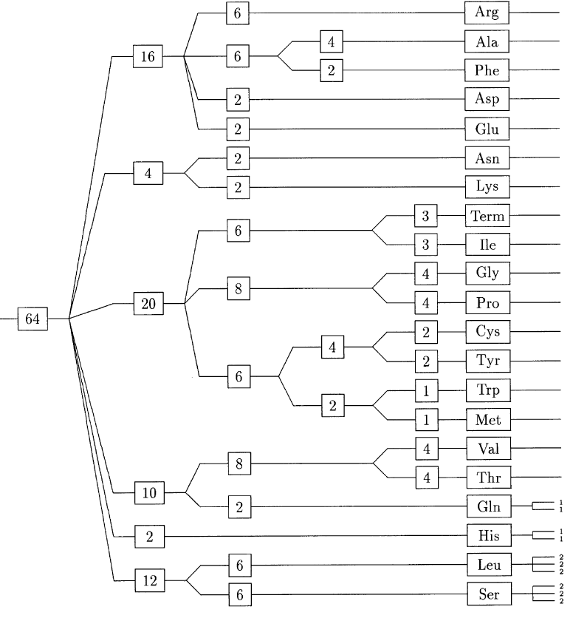

Despite the overwhelming mathematics and physics, biologists may ask: What is the law governing the evolution? What is the origin of symmetry in the genetic code? What triggers its breakdown? Whether the model is able to accommodate the non-universal genetic codes? How (if at all) the structure of the biological machinery of transcription, such as tRNAs and aminoacyl synthetases, fit into the picture suggested by symmetry consideration?

Over the years, biologists accumulate large amount of genetic code variants (Figure 3). Based on these data, they study how changes occur. They found that ancient/recent base modifications, mutation of tRNAs and RNA editing can change the genetic code. There are three main hypothesis attempting to explain variation in the code: ‘codon capture’ hypothesis, ‘ambiguous intermediate’ hypothesis and ‘genome streamlining’ hypothesis, all of which are focused on the mechanism of how the actual codon varies. Predictions are made for code changes that are not yet observed. Biologists are searching for these predicted code changes. Because of the flavor of this class, I stop here without going into details of biologists experiments although I would like to exploit it some more.

Figure 3. Non-universal genetic codes (Knight et al. 2001).

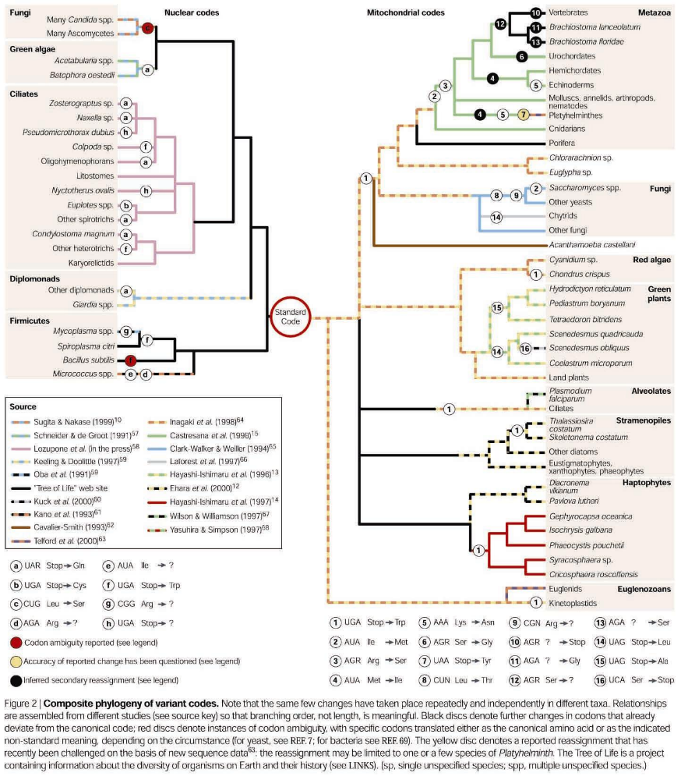

References:
Rosen, G. (1991) Rook’s tour representation of the genetic code. Bulletin of Mathematical Biology. vol. 53, No. 6, pp. 845-851.
Rosen, G. (1999) Molecular content relations in the genetic code. Physics Letters A. 253. pp. 354-357.

Hornos et al. (1999) Symmetry and symmetry breaking: an algebraic approach to the genetic code. International J. Modern Phys. B. Vol. 13, No. 23, pp. 2795-2885.
Forget et al. (2000) Lie superalgebras and the multiplet structure of the genetic code. J. Mathematical Phys. Vol. 41, No. 8, pp. 5407-5444.
Frappat et al. (1999) Symmetry and codon usage correlations in the genetic code. Physics Letters A. 259. pp. 339-348.

Knight et al. (2001) Rewiring the keyboard: evolvability of the genetic code. Nature Reviews Genetics. 2. pp. 49-58.

